1. List full details of all hotels.

ANS: SELECT * FROM hotel;

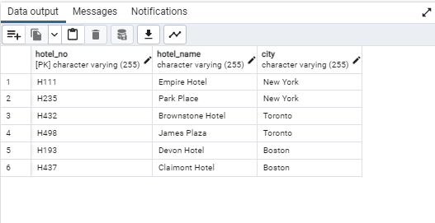

2. List full details of all hotels in New York.

ANS: SELECT * FROM hotel

WHERE city='New York';

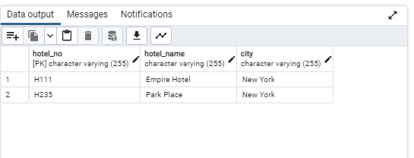

3. List the names and cities of all guests, ordered according to their cities.

ANS: SELECT guest_name, city

FROM guest

ORDER BY city;

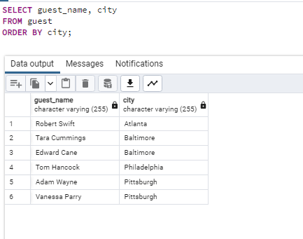

4. List all details for non-smoking rooms in ascending order of price.

ANS: SELECT *

FROM room

WHERE room_type='N'

ORDER BY price ;

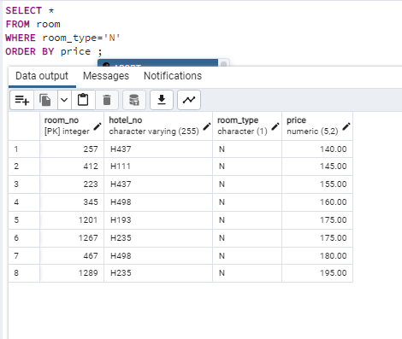

5. List the number of hotels there are.

ANS: SELECT COUNT(hotel_no)

FROM hotel;

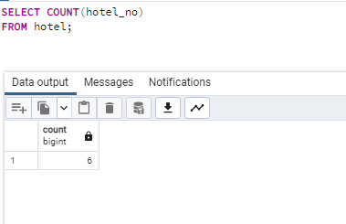

6. List the cities in which guests live. Each city should be listed only once.

ANS: SELECT DISTINCT city

FROM guest;

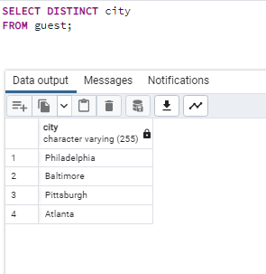

7. List the average price of a room.

ANS: SELECT AVG(price)

FROM room;

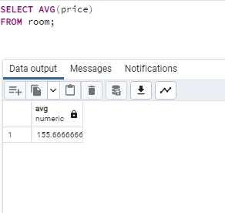

8. List hotel names, their room numbers, and the type of that room.

ANS: SELECT hotel.hotel_name, room.room_no, room.room_type

FROM hotel, room

WHERE hotel.hotel_no = room.hotel_no;

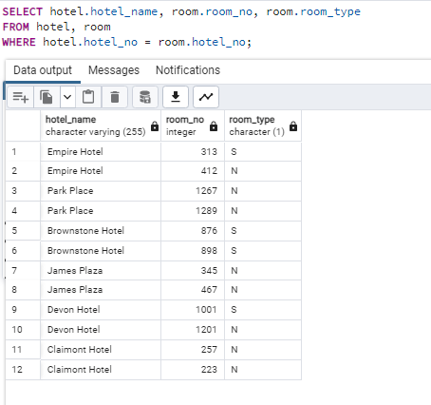

9. List the hotel names, booking dates, and room numbers for all hotels in New York.

ANS: SELECT hotel.hotel_name, booking.date_from, booking.date_to, booking.room_no

FROM hotel, booking

WHERE hotel.hotel_no = booking.hotel_no

AND hotel.city ='New York';

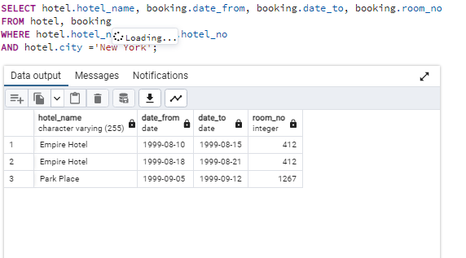

10. What is the number of bookings that started in the month of September?

ANS: SELECT COUNT(date_from)

FROM booking

WHERE date_from BETWEEN '1999-09-01' AND '1999-09-30';

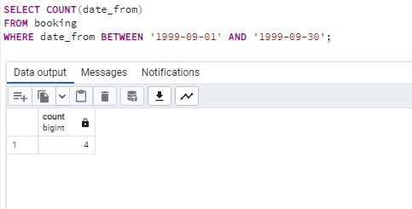

11. List the names and cities of guests who began a stay in New York in August.

ANS: SELECT guest.guest_name, guest.city

FROM hotel, booking, guest

WHERE hotel.hotel_no = booking.hotel_no

AND booking.guest_no = guest.guest_no

AND hotel.city = 'New York'

AND booking.date_from BETWEEN ‘1999-08-01’ AND ‘1999-08-31’;

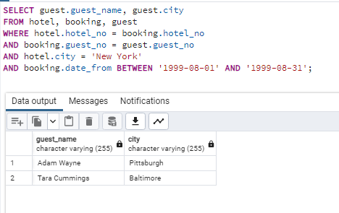

12. List the hotel names and room numbers of any hotel rooms that have not been booked.

ANS: SELECT hotel.hotel_name, booking.room_no

FROM hotel LEFT JOIN booking

ON hotel.hotel_no = booking.hotel_no

WHERE booking.room_no IS NULL;

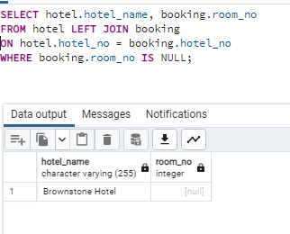

13. List the hotel name and city of the hotel with the highest priced room.

ANS: SELECT hotel.hotel_name, hotel.city

FROM hotel, room

WHERE hotel.hotel_no = room.hotel_no

AND room.price = (SELECT MAX(price) FROM room);

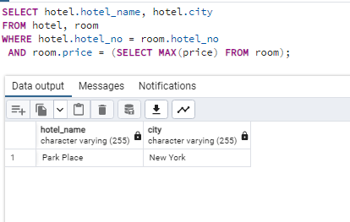

14. List hotel names, room numbers, cities, and prices for hotels that have rooms with prices lower than the lowest priced room in a Boston hotel.

ANS: SELECT hotel.hotel_name, room.room_no, hotel.city, room.price

FROM hotel, room

WHERE hotel.hotel_no = room.hotel_no

AND room.price < (

SELECT price FROM room

GROUP BY room_no

HAVING hotel_no = 'H432'

ORDER BY price

LIMIT 1);

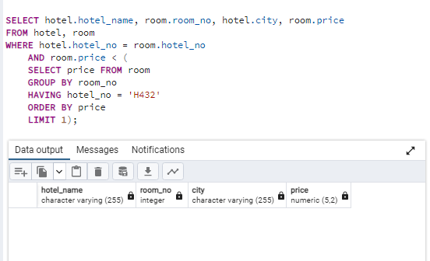

15. List the average price of a room grouped by city.

ANS: SELECT hotel.city, AVG(room.price) FROM room, hotel

WHERE hotel.hotel_no= room.hotel_no

GROUP BY hotel.city;

